Project Report

Date | 14 November 2022
Team ID | PNT2022TMID37430
Team Members | M. Muddasir Ahmad  Mohamed Aadil. A  Dhanush. V  Sanjay Khanna. S
Project Name | Real-Time Communication System Powered by AI for Specially Abled

Table of Contents

- INTRODUCTION

1.1 Project Overview
1.2 Purpose

- LITERATURE SURVEY

2.1 Existing problem
2.2 References
2.3 Problem Statement Definition

- IDEATION & PROPOSED SOLUTION

3.1 Empathy Map Canvas
3.2 Ideation & Brainstorming
3.3 Proposed Solution
3.4 Problem Solution fit

- REQUIREMENT ANALYSIS

4.1 Functional requirement
4.2 Non-Functional requirements

- PROJECT DESIGN

5.1 Data Flow Diagrams
5.2 Solution & Technical Architecture
5.3 User Stories

- PROJECT PLANNING & SCHEDULING

6.1 Sprint Planning & Estimation
6.2 Sprint Delivery Schedule
6.3 Reports from JIRA

- CODING & SOLUTIONING

7.1 Libraries to be installed
7.2 Real time sign to speech
7.3 Facial Emotion Detection
7.4 Language Customization
7.5 Real time speech to text

- TESTING

8.1 Test Cases
8.2 User Acceptance Testing

- RESULTS

9.1 Performance Metrics

- ADVANTAGES & DISADVANTAGES

- CONCLUSION

- FUTURE SCOPE

- APPENDIX

13.1 Source Code
13.2 GitHub & Project Demo Link

- INTRODUCTION:

  - Project Overview

People with impairments are a part of our society. Although technology is constantly evolving, little is being done to improve the lives of these people. The ability to communicate with a deaf-mute person has always been difficult. It is quite challenging for silent persons to communicate with non-mute people because hand sign language is not taught to the general public. It might be quite challenging for them to communicate at times of crisis. In circumstances where other modes of communication, like speech, are not possible, the human hand has remained a common alternative for information transmission. To have proper communication between a normal person and a handicapped person in any language, a voice conversion system with hand gesture recognition and translation will be very helpful.

  - Purpose

The project intends to create a system that can translate speech into specified sign language for the deaf and dumb as well as translate sign language into a human hearing voice in the desired language to communicate a message to normal people. A convolution neural network is being used to build a model that is trained on various hand motions. Based on this model, an app is created. With the help of this app, persons who are deaf or dumb can communicate using signs that are translated into speech and human-understandable words.

- LITERATURE SURVEY

  - Existing Problem

In our society, we have people with disabilities. The technology is developing day by day but no significant developments are undertaken for the betterment of these people. Communications between deaf-mute and a normal person has always been a challenging task. It is complicated for mute people to convey their message to normal people. Since normal people are not trained on hand sign language. In emergency times conveying their message is very difficult. The human hand has remained a popular choice to convey information in situations where other forms like speech cannot be used. Voice Conversion System with Hand Gesture Recognition and translation will be handy to have a proper conversation between a normal person and an impaired person in any language.

  - References

- Design of Communication Interpreter for Deaf and Dumb Person was published by Pallavi Verma (Electrical and Electronics Department, Amity University, Greater Noida, Uttar Pradesh, India), Shimi S. L (Assistant Professor, NITTTR, and Chandigarh, India), Richa Priyadarshani (Electrical and Electronics Department, Amity University, Greater Noida, Uttar Pradesh, India). International Journal of Science and Research (IJSR) · Jan 2013

- At 7th International Conference on Cloud Computing, Data Science & Engineering - Confluence (Confluence) by Surbhi Rathi Department of Information Technology, Yeshwantrao Chavan College of Engineering Nagpur, India and Ujwalla Gawande, Department of Information Technology Yeshwantrao Chavan College of Engineering Nagpur, India.

- A Review Paper on Sign Language Recognition for The Deaf and Dumb published by R Rumana(B.E Graduate(IV year), Department of Computer Science and Engineering, SCSVMV, Kanchipuram) , Reddygari Sandhya Rani(B.E Graduate(IV year), Department of Computer Science and Engineering, SCSVMV, Kanchipuram) , Mrs. R. Prema(Assistant Professor, Department of Computer Science and Engineering, SCSVMV, Kanchipuram). Published (First Online): 01-11-2021

  - Problem Statement Definition

People with disabilities are a part of our society. Even though technology is constantly evolving, little is being done to improve the lives of these people. Communication with a deaf-mute person has always been difficult. Because hand sign language is not taught to the general public, it can be difficult for silent people to communicate with non-mute people. In times of crisis, they may find it difficult to communicate. When other modes of communication, such as speech, are unavailable, the human hand has remained a popular method of information transmission. A voice conversion system with hand gesture recognition and translation will be very helpful in establishing proper communication between a normal person and a handicapped person in any language.

- Ideation and Proposed Solution

  - Empathy Map Canvas

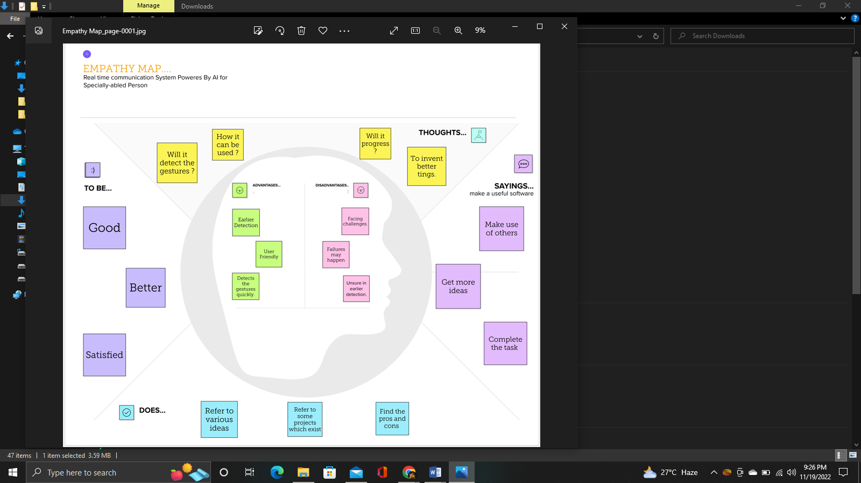

  - Ideation and Brainstorming

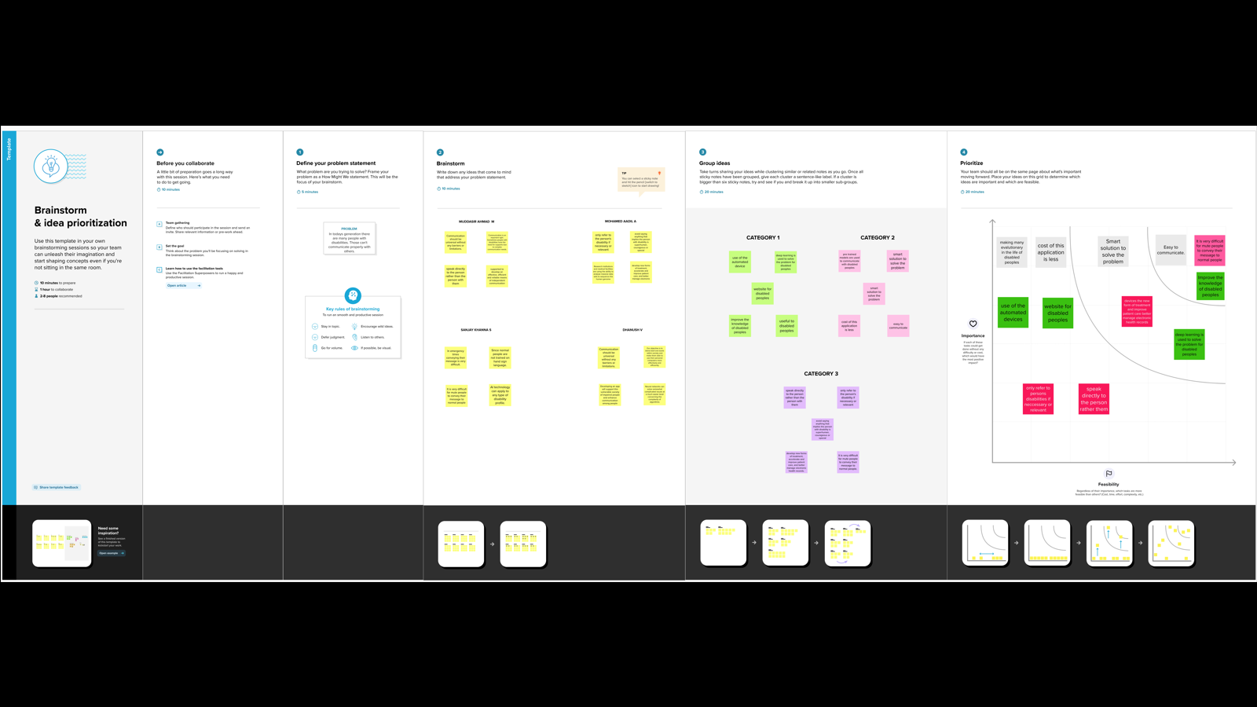

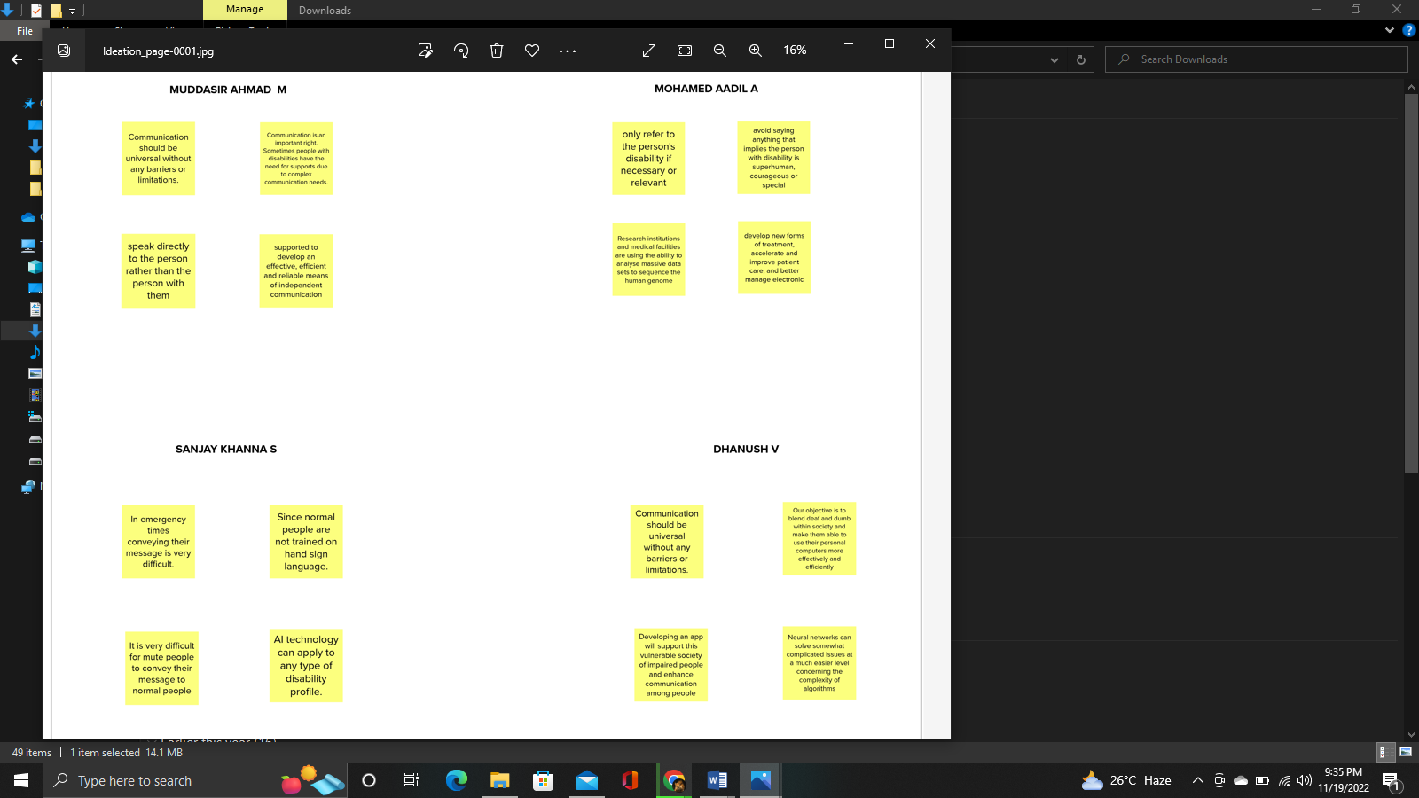
  - Proposed Solution

S No | Parameter | Description
1 | . Problem Statement (Problem to be solved) | In our society, we have people with disabilities. The technology is developing day by day but no significant developments are undertaken for the betterment of these people. Communications between deaf-mute and a normal person has always been a challenging task. It is very difficult for mute people to convey their message to normal people. Since normal people are not trained on hand sign language. In emergency times conveying their message is very difficult. The human hand has remained a popular choice to convey information in situations where other forms like speech cannot be used. Voice Conversion System with Hand Gesture Recognition and translation will be very useful to have a proper conversation between a normal person and an impaired person in any language.
2 | Idea / Solution description | The project aims to develop a system that converts the sign language into a human hearing voice in the desired language to convey a message to normal people, as well as convert speech into understandable sign language for the deaf and dumb. We are making use of a convolution neural network to create a model that is trained on different hand gestures. An app is built which uses this model. This app enables deaf and dumb people to convey their information using signs which get converted to human-understandable language and speech is given as output.
3 | Novelty / Uniqueness | • Facial Emotion Detection  • Language customization  • User-friendly interface.  • Greater accuracy.
4 | Social Impact / Customer Satisfaction | The proposed solution is keen on providing a friendly user interface and user experience. User Interface (UI) is aimed to be developed in such a way that it can be very handy and easy to learn. The system is also aimed to be light weight which would make the system provide faster and accurate results and hence it provides a better User Experience (UX).
5 | . Business Model (Revenue Model) | The proposed solutions help to ease the communication between deaf and dumb people and normal people. The customization and emotion detection feature can make it lot more reliable. Hence, the solution has wide usability and requirement.
6 | Scalability of the Solution | This proposed solution is highly extensible in terms of the features that is been offered by the system. It can be seen as a highly improvised and light weight model when compared to the existing systems. The system can further be scaled in such a way that enables tasks being assigned and completed in system through gestures.

  - Proposed Solution Fit

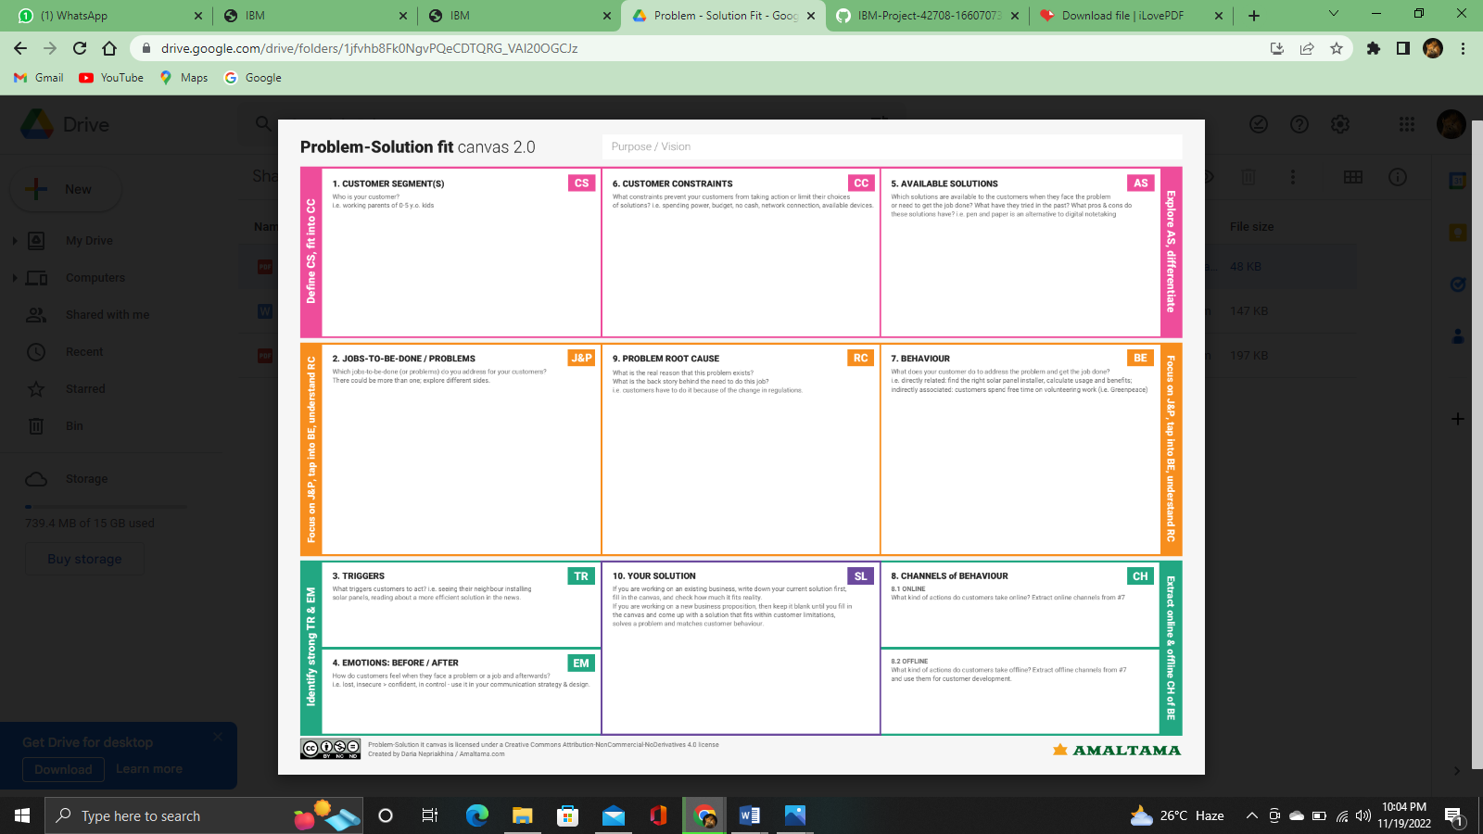
- Requirement Analysis

  - Functional Requirement

FR No | Functional Requirement (Epic) | Sub Requirement (Story / Sub-Task)
FR-1 | Language customization | The user performs language customization.
FR-2 | User Options | The user either chooses to convert speech to sign language and sign language to speech.
FR-3 | Test Inputs | The real time video and audio data is collected and fed into the machine learning model.
FR-4 | Result | The conversion will take place simultaneously and will be displayed on the screen.

  - Non-Functional Requirement

FR No | Non-Functional Requirement | Description
NFR-1 | Usability | The user will have access to all the resources present in that website.
NFR-2 | Security | User information is protected.
NFR-3 | Reliability | It offers accurate results.
NFR-4 | Performance | The web application makes use of light weight model hence the result will be accurate and fast.
NFR-5 | Availability | The web application can be accessed 24/7 from anywhere when connected to the internet.
NFR-6 | Scalability | The trained ML model can provide accurate results whenever the size of the dataset and the number of users is extended.

- Project Design

  - Dataflow Diagram

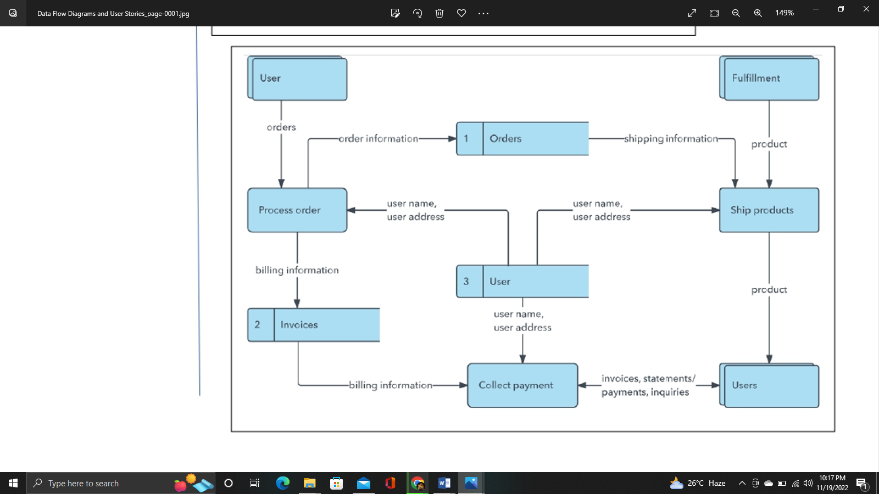

  - Solution and Technical Architecture

Solution Architecture

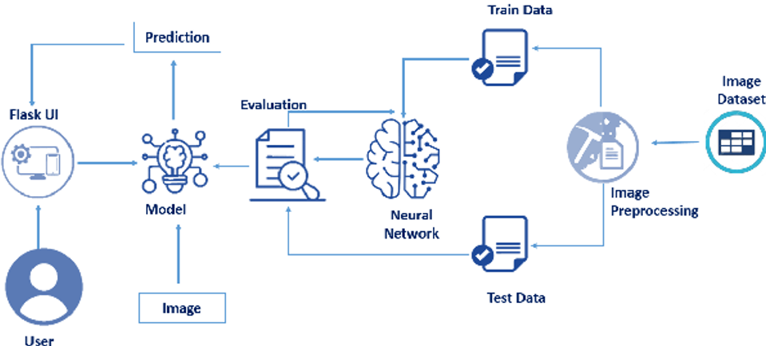

Technical Architecture
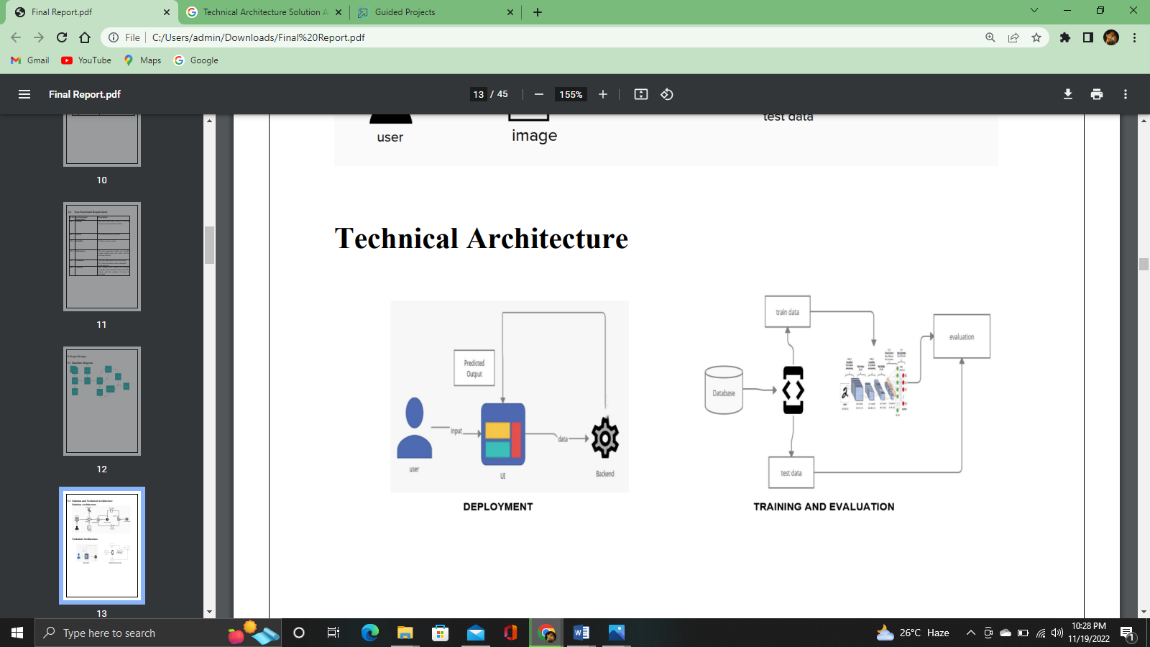
  - User Story

User | Functional Requirement (Epic) | User Story Number | User Story / Task | Acceptance criteria | Priority | Release
Customer | Uploading the real time data. | USN-1 | The user will be presented with two options. 1. Speech to sign language conversion. 2. Sign language to speech conversion. | They can access the portal | High | Sprint-1
 |  | USN-2 | Language selection | They can access the portal | Low | Sprint-1
 |  | USN-3 | The deaf-mute person will choose the speech to sign language conversion which would take them into a portal that collects the real time data (sign language recognition) and converts it into speech simultaneously. | Video processing | High | Sprint-2
 |  | USN-4 | Emotion detection | Video processing | Medium | Sprint-1
 |  | USN-5 | Normal person would choose speech to sign language which would take them into a portal where their speech is converted into sign language simultaneously. | Video and audio processing | High | Sprint-1

- Project Planning and Scheduling

  - Sprint Planning and Estimation

Product Backlog, Sprint Schedule, and Estimation

Sprint | Functional Requirement (Epic) | User Story Number | User Story / Task | Story Points | Priority | Team Members
Sprint-1 | Registration | USN-1 | As a user, I can register for the application by entering my email, password, and confirming my password. | 2 | High
Sprint-1 |  | USN-2 | As a user, I will receive confirmation email once I have registered for the application | 1 | High
Sprint-2 |  | USN-3 | As a user, I can register for the application through Facebook | 2 | Low
Sprint-1 |  | USN-4 | As a user, I can register for the application through Gmail | 2 | Medium
Sprint-1 | Login | USN-5 | As a user, I can log into the application by entering email & password | 1 | High
 | Dashboard

  - Sprint Delivery Schedule

Project Tracker, Velocity & Burn down Chart:

Sprint | Total Story  Points | Duration | Sprint Start Date | Sprint End Date  (Planned) | Story Points  Completed (as on  Planned End Date) | Sprint Release Date  (Actual)
Sprint-1 | 20 | 6 Days | 24 Oct 2022 | 29 Oct 2022 | 20 | 29 Oct 2022
Sprint-2 | 20 | 6 Days | 31 Oct 2022 | 05 Nov 2022
Sprint-3 | 20 | 6 Days | 07 Nov 2022 | 12 Nov 2022
Sprint-4 | 20 | 6 Days | 14 Nov 2022 | 19 Nov 2022

Velocity:

Imagine we have a 10-day sprint duration, and the velocity of the team is 20 (points per sprint). Let’s calculate the team’s average velocity (AV) per iteration unit (story points per day)

Burn down Chart:

A burn down chart is a graphical representation of work left to do versus time. It is often used in agile software development methodologies such as Scrum. However, burn down charts can be applied to any project containing measurable progress over time

  - Reports from JIRA

- Coding and Solutioning

7.1 Libraries to be installed

Pip install fer
Pip install flask
Pip install cv2
Pip install numpy
Pip install keras
Pip install tensorflow
Pip install cvzone
Pip install pyttsx3
Pip install scikit-image

7.2 Real time sign to speech

Sign language is generally used by the people who are unable to speak, for communication. Most people will not be able to understand the Universal Sign Language (unless they have learnt it) and due to this lack of knowledge about the language, it is very difficult for them to communicate with mute people. A device that helps to bridge a gap between mute persons and other people forms the crux of this project. Our system makes use of a model build using CNN that is capable of detection sign languages real time.

7.3 Facial Emotion Detection

Our system makes use of the FER model. Facial Emotion Recognition (commonly known as FER) is one of the most researched fields of computer vision till date and is still in continuous evaluation and improvement. The model is a convolutional neural network with weights saved to HDF5 file in the data folder relative to the module's path. It can be overridden by injecting it into the FER () constructor during instantiation with the emotion model parameter.

7.4 Language Customization

Google Translate is a free multilingual machine translation service. It can translate the Website's text content from one language to another. It offers a huge list of languages to translate and has an efficient, reliable and easy way to translate the webpage in whatever language the user wants. It supports over 100 languages. Use this website translator to convert webpages into your choice of language.

7.5 Real time speech to text

With the Web Speech API, we can recognize speech using JavaScript. It is super easy to recognize speech in a browser using JavaScript and then getting the text from the speech to use as user input. We use the Speech Recognition object to convert the speech into text and then display the text on the screen. Our system is capable of doing this over real time. It is capable of recognizing any languages in which the user is trying to communicate. But the support for this API is limited to the Chrome browser only. So if you are viewing this example in some other browser, the live example below might not work.

8. Testing

8.1 Test Cases
• Verify if user can see the options when user clicks the URL
• Verify if the UI elements are getting displayed properly
• Verify if the user can choose any languages
• Verify if the user is getting redirected to the sign to speech page
• Verify if the application can convert the sign to speech
• Verify if the user can exit the sign to speech page
• Verify if the user is getting redirected to the speech to sign page
• Verify if the UI elements are being displayed
• Verify if the application can convert speech to text on clicking voice to text button.
• Verify if the user can exit the speech to sign page.
8.2 UAT Testing
1. Defect Analysis
This report shows the number of resolved or closed bugs at each severity level, and how they were resolved

Resolution | Severity 1 | Severity 2 | Severity 3 | Severity 4 | Subtotal
By Design | 11 | 7 | 4 | 2 | 24
Duplicate | 1 | 0 | 2 | 0 | 3
External | 2 | 3 | 2 | 1 | 8
Fixed | 10 | 5 | 3 | 14 | 32
Not Reproduced | 0 | 0 | 1 | 0 | 1
Skipped | 0 | 0 | 1 | 1 | 2
Won't Fix | 1 | 0 | 0 | 0 | 1
Totals | 25 | 15 | 13 | 18 | 71

2. Test Case Analysis
This report shows the number of test cases that have passed, failed, and untested

Section | Total Cases | Not Tested | Fail | Pass
Print Engine | 7 | 0 | 0 | 7
Client Application | 15 | 0 | 0 | 15
Security | 2 | 0 | 0 | 2
Print Engine | 7 | 0 | 0 | 7
Client Application | 15 | 0 | 0 | 15
Security | 2 | 0 | 0 | 2

8.3 Performance Testing

S.NO | Parameter | Values | Screenshot
1 | Model Summary | Total params: 1,103,721  Trainable params: 1,103,721  Non-trainable params: 0
2 | Accuracy | Training Accuracy - 0.9994  Validation Accuracy -0.9969

9. Results

Performance Metrics

The following images can be studied to understand the performance metrics of our system

10. Advantages and Disadvantages

Advantages:

• Real time sign to speech detection.
• Model provides good accuracy.
• Real time facial emotion detection.
• Language Customization.
• Real time speech to text conversion.
• Friendly UI
• Data privacy

Disadvantages:

• At times the website may lag.
• Model is not tested on a wide set of data set, having all the signs.
• Sign language customization feature is not available.
• User cannot take notes while using the app.
• User cannot make calls using the app.
• Speech recognition works only on google chrome.

11. Conclusion

Communication is crucial for self-expression. Additionally, it meets one's necessities. Effective communication is necessary for career advancement. Effective communication skills can make your personal life easier and improve your interactions with others by facilitating mutual understanding. A system that translates speech into acceptable sign language for the deaf and dumb has been developed as part of our project. It also translates sign language into a human hearing voice to communicate with average people. A convolution neural network has been used to build a model that is trained on various hand motions. Utilizing this concept, an app is created. Through the use of signs that are translated into speech and human-understandable English, this software aids deaf and dumb individuals to communicate easily.

12. Future Scope

The following are the features that can be added in our application:

• A communication app can be built with the same set of features. The user can choose the appropriate mode (speech to sign or sign to speech) and accordingly the real time detection would take place on both the end users’ application.
• The accuracy of the model shall be increased.
• Customization of languages shall be added.
• Users shall be allowed to write notes while on call.
• Customization of signs can also be added as a feature.

13. Appendix

Source Code

Model Building

import cv2
import os
os.environ['TF_CPP_MIN_LOG_LEVEL'] = '2'
import numpy as np
from keras.models import Sequential
import matplotlib.pyplot as plt
from keras.layers import Dense, Dropout, Activation, Flatten
from keras.layers import Conv2D, MaxPool2D
from keras_preprocessing.image import ImageDataGenerator
test_path = 'Dataset/test_set'
train_path = 'Dataset/training_set
train=ImageDataGenerator(rescale=1./255,zoom_range=0.2,shear_range=0.2,horizontal_flip=True)
test=ImageDataGenerator(rescale=1./255)
train_batches = train.flow_from_directory(directory=train_path, target_size=(64,64), class_mode='categorical', batch_size=300,shuffle=True,color_mode="grayscale")
test_batches = test.flow_from_directory(directory=test_path, target_size=(64,64), class_mode='categorical', batch_size=300, shuffle=True,color_mode="grayscale")
model = Sequential()
model.add(Conv2D(32, kernel_size=(3, 3), activation='relu', input_shape=(64,64,1)))
model.add(MaxPool2D(pool_size=(2,2)))
model.add(Conv2D(512, (3, 3), padding="valid"))
model.add(MaxPool2D(pool_size=(2,2)))
model.add(Conv2D(32, (3, 3), padding="same"))
model.add(MaxPool2D(pool_size=(2,2)))
model.add(Flatten())
model.add(Dense(512,activation ="relu"))
model.add(Dense(9,activation ="softmax"))
model.compile(optimizer='adam', loss='categorical_crossentropy', metrics=['accuracy'])
history = model.fit(train_batches, batch_size=32,validation_data=test_batches,epochs=25)
model.save('model.h5')

Model Testing

import keras
from keras.models import load_model
import cv2
import numpy as np
import os
os.environ['TF_CPP_MIN_LOG_LEVEL'] = '2'
val=['A','B','C','D','E','F','G','H','I']
model=load_model('model.h5')
from skimage.transform import resize
def detect(frame):
img=resize(frame,(64,64,1))
img=np.expand_dims(img,axis=0)
if(np.max(img)>1):
img = img/255.0
predict_x=model.predict(img)
print(predict_x)
predict=np.argmax(predict_x,axis=1)
x=predict[0]
print(val[x])
frame=cv2.imread(r"C:\Users\Akshaya\PycharmProjects\Realtime_Communication_System_For_Specially_Abled\Dataset\test_set\B\1.png")
data=detect(frame)

Flask App Building

import numpy as np
import os
import math
import cv2
from fer import FER
import pyttsx3
from keras.models import model_from_json
os.environ['TF_CPP_MIN_LOG_LEVEL'] = '2'
from keras.models import load_model
from flask import Flask, render_template, Response, request
import tensorflow as tf
from cvzone.HandTrackingModule import HandDetector
from skimage.transform import resize
facecascade= cv2.CascadeClassifier("haarcascade_frontalface_default.xml")
graph=tf.compat.v1.get_default_graph()
writer=None
model=load_model('model.h5')
font = cv2.FONT_HERSHEY_SIMPLEX
vals=['A','B','C','D','E','F','G','H','I']
emotion_detector = FER(mtcnn=True)
app=Flask(__name__,template_folder="template")
print("Accessing video stream")
app.static_folder = 'static'
vs=cv2.VideoCapture(0)
detector=HandDetector(maxHands=1)
pred=""
def SpeakText(command):
engine = pyttsx3.init()
engine.say(command)
engine.runAndWait()
def generate_frames():
while (vs.isOpened()):
success, frame = vs.read()
hands, frame=detector.findHands(frame)
dominant_emotion, emotion_score = emotion_detector.top_emotion(frame)
if not success:
break
else:
if hands:
hand=hands[0]
x,y,w,h=hand['bbox']
imgCrop=frame[y-20:y+h+20,x-20:x+w+20]
black=np.ones((300,300,3), np.uint8)*0
ishape=imgCrop.shape
if h/w>1:
k=300/h
wcal=math.ceil(k*w)
imgresize=cv2.resize(imgCrop,(wcal,300))
irshape=imgresize.shape
wgap=math.ceil((300-wcal)/2)
black[:,wgap:wcal+wgap]=imgresize
else:
k=300/w
hcal=math.ceil(k*h)
imgresize=cv2.resize(imgCrop,(300,hcal))
irshape=imgresize.shape
hgap=math.ceil((300-hcal)/2)
black[hgap:hcal+hgap,:]=imgresize
img=resize(black,(64,64,1))
img=np.expand_dims(img,axis=0)
if(np.max(img)>1):
img = img/255.0
predict_x=model.predict(img)
classes_x=np.argmax(predict_x,axis=1)
x=classes_x[0]
SpeakText(vals[x])
dominant_emotion=str(dominant_emotion)
if(dominant_emotion!=""):
value=vals[x] +" "+ dominant_emotion
else:
value=vals[x]
cv2.putText(frame,value,(x+20,y+20),cv2.FONT_HERSHEY_SIMPLEX, 1,(255, 255, 150),2,cv2.LINE_AA)
ret, buffer = cv2.imencode('.jpg', frame)
frame = buffer.tobytes()
yield (b'--frame\r\n'
b'Content-Type: image/jpeg\r\n\r\n' + frame + b'\r\n')
@app.route('/')
def index():
return render_template('index.html')
@app.route('/sign_to_speech')
def sign_to_speech():
return render_template('sign_to_speech.html')
@app.route('/speech_to_sign')
def speech_to_sign():
return render_template('speech_to_sign.html')
@app.route('/video',methods=['GET', 'POST'])
def video():
return Response(generate_frames(), mimetype='multipart/x-mixed-replace; boundary=frame')
if (__name__ == "__main__"):
app.run(debug=True)

HTML Files

index.html
<!DOCTYPE html>
<html lang="en">
<head>
<style>
body{
background-image: url("https://image.shutterstock.com/image-vector/deaf-sign-language-welcome-line-260nw-1585429861.jpg");
background-repeat: no-repeat;
background-size: cover;
}
</style>
<script>
function loadGoogleTranslate()
{
new google.translate.TranslateElement("element")
}
</script>
<script src="http://translate.google.com/translate_a/element.js?cb=loadGoogleTranslate"></script>
<meta charset="UTF-8" />
<meta http-equiv="X-UA-Compatible" content="IE=edge" />
<meta name="viewport" content="width=device-width, initial-scale=1.0" />
<title>Document</title>
<link rel="stylesheet" href="{{ url_for('static', filename='css/index.css') }}" />
</head>
<body>
<section class="main">
<div class="inside">
<div class="wrapper">
<div class="Head">
<h1>Welcome</h1>
<span></span>
<div id="element"></div>
</div>
<a class="box1 box" href="sign_to_speech">Sign to speech</a>
<a class="box1 box" href="speech_to_sign">Speech to sign</a>
</div>
</div>
</section>
</body>
</html>
Speech_to_sign,html
<html>
<head>
<meta charset="utf-8">
<meta http-equiv="X-UA-Compatible" content="ie=edge">
<meta name="viewport" content="width=device-width, initial-scale=1">
<script src="http://translate.google.com/translate_a/element.js?cb=loadGoogleTranslate"></script>
<script>
function loadGoogleTranslate()
{
new google.translate.TranslateElement("google_element")
}
</script>
<script src="https://ajax.googleapis.com/ajax/libs/jquery/3.6.0/jquery.min.js"></script>
<script src="https://maxcdn.bootstrapcdn.com/bootstrap/3.4.1/js/bootstrap.min.js"></script>
<link rel="stylesheet" href="https://maxcdn.bootstrapcdn.com/bootstrap/3.4.1/css/bootstrap.min.css">
<style>
.row {
display: flex;
}
.col {
flex: 50%;
}
*,*:after,*:before{
-webkit-box-sizing: border-box;
-moz-box-sizing: border-box;
-ms-box-sizing: border-box;
box-sizing: border-box;
}
body{
font-family: arial;
font-size: 16px;
margin: 0;
color: #000;
display: flex;
align-items: center;
justify-content: center;
min-height: 100vh;
}
.voice_to_text{
width: 600px;
text-align: center;
}
h1{
color: #000000;
font-size: 50px;
}
#convert_text{
width: 100%;
height: 200px;
border-radius: 10px;
resize: none;
padding: 10px;
font-size: 20px;
margin-bottom: 10px;
}
button{
padding: 12px 20px;
background: #0ea4da;
border: 0;
color: #fff;
font-size: 18px;
cursor: pointer;
border-radius: 5px;
}
</style>
</head>
<body>
<div class="container">
<div class="row">
<div class="col">
<img src="https://img.freepik.com/free-vector/sign-language-alphabet-hand-drawn-style_23-2147872270.jpg?w=2000" style="width:50%;"/>
</div>
<div class="col"><div class="voice_to_text">
<div class="text_center" id="google_element"></div>
<h1>Voice to text converter</h1>
<textarea name="" id="convert_text"></textarea>
<button id="click_to_record" class="btn-primary">Voice to Text</button><br/>
<a href="/">
<button class="btn btn-danger btn-lg">Exit</button>
</a>
</div>
</div></div></div>
<script type="text/javascript" src="{{ url_for('static', filename='javascript/script.js') }}"></script>
</body>
</html>
Sign_to_speech.html
<html>
<head>
<style>
img{
display: block;
margin-left: auto;
margin-right: auto;
}
</style>
<script>
function loadGoogleTranslate()
{
new google.translate.TranslateElement("google_element")
}
</script>
<script src="http://translate.google.com/translate_a/element.js?cb=loadGoogleTranslate"></script>
<script src="https://ajax.googleapis.com/ajax/libs/jquery/3.6.0/jquery.min.js"></script>
<script src="https://maxcdn.bootstrapcdn.com/bootstrap/3.4.1/js/bootstrap.min.js"></script>
<link rel="stylesheet" href="https://maxcdn.bootstrapcdn.com/bootstrap/3.4.1/css/bootstrap.min.css"/>
</head>
<body>
<h1>Sign to speech</h1>
<div>
<div class="text-center" id="google_element"></div>
<img src="{{ url_for('video') }}" width="50%" height="50%"/>
<br/>
<div class="text-center">
<a href="/">
<button class="btn btn-danger btn-lg" >Exit</button>
</a></div>
</div>
</body>
</html>

CSS Files

Index.css
@import url("https://fonts.googleapis.com/css2?family=Oxygen:wght@400;700&family=Roboto:wght@300;900&display=swap");
* {
box-sizing: border-box;
padding: 0;
margin: 0;
}
:root {
--black: #000;
--white: #fff;
--hover: #000;
}
.main {
position: relative;
height: 100vh;
width: 100%;
display: flex;
align-items: center;
justify-content: center;
}
.inside {
position: relative;
height: 60%;
width: 50%;
background: rgba(255,255,255,0.9);
border-radius: 30px;
/* border: 5px solid var(--black); */
display: flex;
align-items: center;
justify-content: space-evenly;
-webkit-box-shadow: 12px 12px 17px 1px rgba(0, 0, 0, 0.59);
-moz-box-shadow: 12px 12px 17px 1px rgba(0, 0, 0, 0.59);
box-shadow: 12px 12px 17px 1px rgba(0, 0, 0, 0.59);
}
.wrapper {
position: relative;
height: 75%;
width: 30%;
display: flex;
align-items: center;
justify-content: space-evenly;
flex-direction: column;
}
.Head {
position: relative;
font-size: 3rem;
text-transform: uppercase;
font-family: "Roboto", sans-serif;
font-weight: 900;
display: flex;
align-items: center;
justify-content: center;
flex-direction: column;
height: 30%;
}
.Head h1 {
font-size: 3rem;
}
.Head span {
position: relative;
height: 5px;
width: 60%;
background: var(--black);
}
.box {
position: relative;
font-family: "Oxygen", sans-serif;
font-weight: 700;
border: 2px solid var(--black);
border-radius: 1.5rem;
text-decoration: none;
overflow: hidden;
cursor: pointer;
z-index: 1;
}
.box1 {
padding: 0.8rem 2rem;
}
.box2 {
padding: 0.8rem 1.5rem;
}
.box:hover {
color: var(--white);
background: var(--hover);
}

Javascript Files

Script.js
click_to_record.addEventListener('click',function(){
var speech = true;
const SpeechRecognition = window.speechRecognition || window.webkitSpeechRecognition;
const recognition =new SpeechRecognition();
recognition.interimResults = true;
recognition.addEventListener('result', e => {
const transcript = Array.from(e.results)
.map(result => result[0])
.map(result => result.transcript)
.join('')
document.getElementById("convert_text").innerHTML = transcript;
console.log(transcript);
});
if (speech == true) {
recognition.start();
}
})

Output

13.2 Github and Demo Link:

https://drive.google.com/file/d/1Yw1uTOi5YborPnG8Y4joLJlC_VD2Sjif/view?usp=share_link

